Data Acquisition 2
Respiration Sensing 2
Heart Rate Variability 3
Electrodermal Activity 3
Real-Time Cloud Telemetry 4
System Architecture 4
Database Schema 5
Performance & Integrity Considerations 6
Signal Processing 7
Respiration Metrics 7
Heart Rate Metrics 7
Galvanic Skin Response 8
Session Analysis 9
Tri-Phasic Session Design 10
Preprocessing & Artifact Rejection 10
Post-Hoc Analysis & Report Generation 11
Hardware Validation 12
Respiration Monitoring 12
Validation Protocol 12
Statistical Analysis 13
Evaluation Results 14
Heart Rate Monitoring 15
Validation Protocol 15
Statistical Analysis 16
Evaluation Results 18
Galvanic Skin Response 19
Validation Protocol 19
Statistical Analysis 20
Evaluation Results 21

Methodology

Data Acquisition

Respiration Sensing
The core of the respiration sensing apparatus is formed by an MPU6050 Inertial Measurement Unit (IMU), which integrates a 3-axis gyroscope and a 3-axis accelerometer. For our application, the y-axis of the gyroscope was selected for polling, which, given the defined sensor placement, corresponds to angular velocity in the sagittal plane. This axis directly measures the anteroposterior tilting motion of the torso, which has been empirically shown to exhibit the most robust correlation with respiratory effort.
Communication is established via the I2C protocol, configuring specific hardware registers to optimize for respiration biomechanics upon initialization. The firmware implements a sequential, real-time algorithm designed to process each incoming gyroscopic sample and update respiratory parameters. The algorithm is structured as a three-stage pipeline: noise mitigation, respiratory phase detection, and parameter computation.
- Noise Mitigation via Moving Average Filter: Although the hardware DLPF removes substantial noise, residual high-frequency components inherent to MEMS sensors can persist. To address this, a software-based moving average filter is applied as the first processing step. The algorithm maintains a circular buffer of the eight most recent raw y-axis gyroscope samples. For each new sample, the buffer is updated, and the arithmetic mean is computed. This low-pass filtering operation effectively attenuates spurious fluctuations while preserving the underlying morphology of the respiratory waveform, a critical prerequisite for accurate event detection in a largely event-driven architecture.

- Respiratory Phase Detection via Finite State Machine: The core of the respiratory cycle detection is a finite state machine (FSM) with three distinct states: i) Idle, ii) Inhaling, and iii) Exhaling. Transitions between these states are governed by the smoothed angular velocity signal crossing empirically determined and calibrated thresholds:
  - Idle to Inhaling Transition: The system remains in the Idle state until the smoothed angular velocity signal deflects negatively, crossing a threshold of -0.05 rad/s. This event signifies the posterior tilt of the torso at the onset of inhalation. Upon this transition, the current system time is recorded as the inhaleStartTime.
  - Inhaling to Exhaling Transition: During the Inhaling state, the signal typically reaches a negative peak. As the subject begins to exhale, the torso tilts anteriorly, causing the angular velocity to increase. The transition to the Exhaling state is triggered when the positive-going signal crosses a threshold of +0.05 rad/s. The timestamp of this crossing is recorded as the exhaleStartTime.
  - Exhaling to Idle Transition: A full respiratory cycle is deemed complete when the signal, after its positive peak during exhalation, returns towards the baseline. To sensitively capture the gentle, tail-end of the expiratory phase, a more relaxed threshold of +0.01 rad/s is used. When the signal drops below this value, the FSM transitions bac to the Idle state, signifying the completion of one breath.

- Parameter Computation and Buffering: Upon the successful completion of a breath cycle (transitioning from Exhaling to Idle), the algorithm computes the key respiratory parameters. First, a validity check is performed to ensure the total duration of the breath (currentTime - inhaleStartTime) falls within a physiologically plausible range of 500 ms to 15,000 ms, thereby filtering out motion artifacts such as coughs or brief sighs.
For valid breaths, the duration of the inhalation phase (exhaleStartTime - inhaleStartTime) and exhalation phase (currentTime - exhaleStartTime) are calculated. From these, the dimensionless Inhale/Exhale (I/E) ratio is computed.
To ensure a stable and robust Respiration Rate (RR) calculation, the timestamp of each completed breath is stored in a 15-element circular buffer (BREATH_HISTORY_SIZE = 15). The RR, in breaths per minute (BPM), is then calculated based on the time elapsed over the number of breaths currently stored in this buffer. This rolling average approach mitigates the impact of single-breath anomalies and provides a more stable, representative measure of the current respiratory frequency.

Heart Rate Variability
The system is architected around the AD8232, a dedicated analog front-end (AFE) integrated circuit designed for clinical grade biopotential signal conditioning. Its selection was predicated on its high common-mode rejection ratio (CMRR > 80 dB), low power consumption, and integrated filtering capabilities, which are critical for mitigating noise in ambulatory monitoring applications. A standard three-electrode, single-lead configuration (approximating Lead I) is employed for signal acquisition, utilizing disposable Ag/AgCl electrodes.
The AD8232 module performs several critical analog signal processing steps. An internal instrumentation amplifier provides high-gain amplification of the low-amplitude (~1 mV) ECG signal. This is followed by a two-pole high-pass filter to eliminate baseline wander caused by respiration and electrode motion, and a two-pole active low-pass filter to attenuate high-frequency noise, primarily from electromyographic (EMG) artifacts and power line interference.
The conditioned analog output from the AD8232 is digitized by the integrated 12-bit analog-to-digital converter (ADC) of an ESP32 microcontroller. The data acquisition driver, implemented in the firmware, establishes a consistent sampling frequency of 250 Hz. This rate was selected as it provides the necessary temporal resolution (4 ms) for precise morphological analysis of the QRS complex, which is essential for accurate R-peak localization and the subsequent calculation of beat-to-beat intervals required for HRV analysis.

Electrodermal Activity
The core of the electrodermal activity (EDA) data acquisition system is a two-electrode bipolar sensor array designed to measure changes in skin impedance, which is inversely proportional to skin conductance. The sensor interfaces directly with the analog input of an ESP32 microcontroller, leveraging its integrated 12-bit analog-to-digital converter (ADC) for digitization. The ADC is configured for its full operational range (0-3.3V), providing a resolution of 4096 discrete levels.
The data acquisition driver, implemented in the device firmware, establishes a consistent and stable sampling frequency of 10 Hz, corresponding to a sampling interval of 100 milliseconds (GSR_INTERVAL = 100). This rate was determined to be optimal for capturing the full spectrum of EDA phenomena; it is well above the Nyquist frequency required for the slow-moving tonic component of skin conductance level (SCL) and is sufficient to accurately characterize the morphology of the more rapid, event-related phasic components, known as skin conductance responses (SCRs), which typically have a rise time of 1-3 seconds. The firmware's primary role is to perform a direct, unfiltered acquisition of the raw ADC values. This minimalist on-device processing approach ensures that the full, unprocessed signal is preserved and transmitted for more computationally intensive offline analysis, thereby maximizing battery life and ensuring signal integrity.

Real-Time Cloud Telemetry
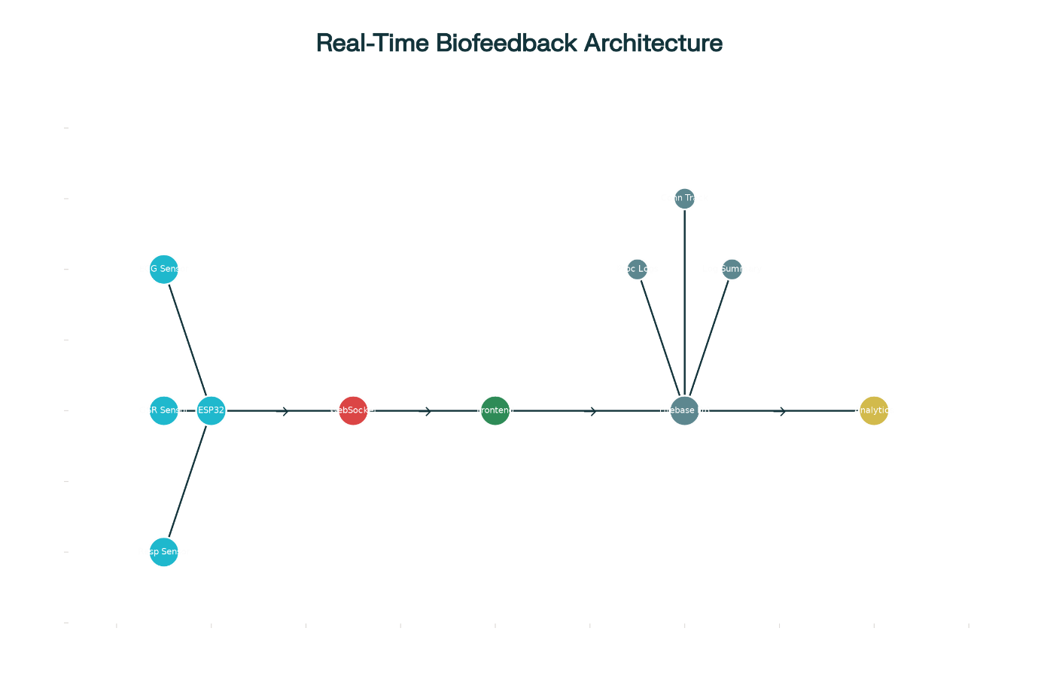
Figure 1: System architecture diagram showing the flow of biofeedback data from ESP32 sensors through frontend processing to Firebase cloud storage and subsequent analytical processing for research applications.
To support longitudinal biofeedback research, facilitate remote physiological monitoring, and enable the deployment of computationally intensive machine learning algorithms, a scalable and robust cloud-based data logging and storage architecture was implemented. This infrastructure serves as the central repository for the high-frequency, multi-modal physiological data streams generated by the wearable sensor platform. The architecture aligns with contemporary Internet of Things (IoT) paradigms for remote health monitoring while providing a persistent, queryable, and analytically accessible foundation for advanced biofeedback research.

System Architecture
The data acquisition and transmission pipeline is architected as a multi-tiered system, a design pattern that ensures both high-fidelity signal capture at the edge and robust, reliable data integrity in the cloud. This architecture strategically distributes computational load and decouples system components to maximize performance and resilience.
- Edge Tier (Wearable Sensor Platform): At the primary data source, the ESP32-based wearable device is responsible for the high-frequency tasks of signal acquisition from the suite of bio-sensors (AD8232 ECG, GSR sensor, MPU6050 IMU). It performs essential on-device, real-time processing to derive foundational physiological parameters such as raw R-R intervals and respiration cycles. Processed data is encapsulated into JSON-formatted packets and transmitted over a low-latency WebSocket protocol.
- Middleware Tier (Client Application): A client-side application, implemented in TypeScript, serves as an essential middleware layer. This architectural choice decouples the resource-constrained microcontroller from the complexities and overhead of direct cloud communication. The middleware establishes a persistent WebSocket connection to the wearable device, receiving the real-time data stream. Its primary responsibilities are multifaceted: (a) rendering immediate, real-time visualizations of the physiological waveforms for user biofeedback and researcher oversight; (b) executing more computationally demanding signal processing algorithms in real-time, such as the comprehensive calculation of a full suite of Heart Rate Variability (HRV) metrics from the incoming R-R intervals; and (c) securely authenticating with and transmitting the enriched data packets to the cloud backend.
- Cloud Tier (Data Persistence and Analysis): The cloud backend provides a scalable, secure, and globally accessible repository for the aggregated physiological time-series data, enabling both real-time multi-client synchronization and sophisticated post-hoc analysis.
Google's Firebase Realtime Database was selected as the primary cloud backend technology. This selection was predicated on several key platform features that are highly advantageous for research-grade, real-time biofeedback applications:
- Real-Time Data Synchronization: The platform's core capability is the synchronization of data across all connected clients in near real-time, typically within milliseconds. This is a fundamental requirement for applications involving live remote monitoring and for advanced biofeedback paradigms that may incorporate cloud-based algorithmic responses
- Flexible Schema-on-Read Data Model: The database stores data as a single, large JSON tree. This NoSQL structure offers a highly flexible schema that can be dynamically evolved to accommodate new sensors, derived metrics, or modified data structures without requiring complex database migrations—a significant advantage in an agile research and development environment.
- Offline Persistence and Resilience: The client-side SDK provides robust offline data persistence, automatically caching data locally when network connectivity is lost and seamlessly synchronizing it with the server upon reconnection. This is a critical feature for ensuring complete data integrity in ambulatory monitoring scenarios where network connectivity may be intermittent.

Database Schema
The database schema is logically structured as a hierarchical JSON tree, meticulously designed to support efficient querying for both real-time visualization and complex longitudinal analysis. The schema is organized around several primary nodes, each serving a distinct and critical function as evidenced by the system's implementation.
- processed_sensor_logs: This is the principal node for the persistent storage of comprehensive, time-series physiological data. Each child entry within this node is assigned a unique, chronologically sortable key generated by Firebase's push() method. A single entry in this log represents a complete snapshot of the user's physiological state at a discrete point in time and is structured according to the ProcessedSensorData interface. The richness of this data model is a key feature of the architecture, capturing:
  - Cardiovascular Metrics: A nested object containing not only fundamental parameters like heartRate but also a comprehensive suite of 30+ HRV metrics. This encompasses standard time-domain (sdnn, rmssd, pnn50), frequency-domain (lfPower, hfPower, vlfPower, totalPower, lfHfRatio), and advanced non-linear measures (apEn, sampEn, dfa, Poincaré plot descriptors sd1 and sd2).
  - Respiratory Metrics: A detailed object capturing not just the respiratoryRate, but also dynamic characteristics of breathing such as inhalePercent, exhalePercent, estimated tidalVolume, minuteVolume, inspiratoryExpiratoryRatio, and metrics of breathingRegularity and respiratorySinusArrhythmia.
  - Electrodermal Activity Metrics: Includes the raw gsrValue and the algorithmically derived gsrTrend (e.g., "increasing", "decreasing", "stable").
  - System and Data Provenance Metadata: Each log entry is critically enriched with metadata to ensure scientific rigor. This includes a high-precision timestamp, a unique logId corresponding to the Firebase push key, a logSequence number for verifying data continuity, and a dataSource field ("Real Sensors (ESP32 Connected)" vs. "Fallback Data (ESP32 Disconnected)") that explicitly tags the provenance of the data. An embedded connectionStatus object provides a snapshot of the hardware's operational state at the moment of data capture.
- logs_summary: This node functions as a high-level, low-bandwidth endpoint for monitoring the data logging process. It stores aggregated metadata about the entire logging session, including the totalLogs count, the lastLogTime, and a complete copy of the lastLogData packet. This structure enables efficient queries to check system status without needing to traverse the larger, and potentially vast, processed_sensor_logs node.
- events, errors, and connection_test: These nodes provide a robust framework for system diagnostics and auditing. The connection_test node is used by the client logger's testConnection method to verify read/write permissions and network pathing upon initialization. The events and errors nodes are used to log system-level occurrences, such as connection status changes or software exceptions, providing a crucial audit trail for debugging and system performance analysis.

Performance & Integrity Considerations
A multi-layered approach is implemented to ensure the integrity, quality, and security of the collected physiological data throughout its lifecycle.
- Data Provenance and Quality Tagging: The system architecture explicitly distinguishes between data originating from the physical sensors and synthetically generated "fallback data" used during periods of hardware disconnection. The dataSource field is a critical component of this framework, allowing for the automated filtering of invalid data during post-hoc analysis. Furthermore, derived metrics such as ecgQuality, hrvMetrics.signalQuality, and hrvMetrics.noiseLevel provide a quantitative score of signal fidelity for each data snapshot.
- Systematic Logging Protocol: As implemented in the FirebaseLogger class, data is logged to the persistent processed_sensor_logs node at a fixed interval of 30 seconds (LOG_INTERVAL). This rate was strategically chosen to balance the need for high-temporal-resolution trend analysis with considerations for cloud storage efficiency and cost, making it feasible for long-term, multi-day studies.
- Connection and Error Handling: The client-side logger includes robust error handling and a proactive connection testing method (testConnection). It can detect and log specific Firebase errors (e.g., PERMISSION_DENIED, UNAVAILABLE, QUOTA_EXCEEDED), providing a rich diagnostic framework for system maintenance and troubleshooting.
- Security: Data transmission between the client application and the Firebase backend is secured using Transport Layer Security (TLS) encryption by default. While the current development configuration employs open security rules for ease of testing (as noted in the Firebase console), a production deployment would enforce strict security rules, restricting read and write access to authenticated users only, thereby ensuring compliance with data privacy standards for human subjects’ research.

Signal Processing

Respiration Metrics
The MPU6050’s internal Digital Low-Pass Filter (DLPF) was enabled and configured to a bandwidth of 21Hz. This hardware-level filtering serves as reliable defence against high-frequency noise and mechanical vibrations, ensuring a cleaner signal for subsequent high-level processing.
The gyroscope’s full-scale range was set to +/- 250 degrees per second. This sensitivity level provides an optimal balance, ensuring that the low-amplitude angular velocities characteristics of thoracic movement are captured at a sufficiently high resolution- avoiding saturation during more pronounced motions like coughing or postural shifts.
The driver is designed to operate at a fixed sampling frequency of 50Hz, corresponding to a sampling interval of 20milliseconds. This rate was empirically determined to satisfy the Nyquist criterion for typical human respiratory patterns (which rarely exceed 1Hz or 60 BPM) while providing sufficient temporal resolution to accurately characterize the waveform morphology of both inhalation and exhalation phases.

Heart Rate Metrics
The foundational step for all cardiac analysis is the reliable detection of R-peaks from the digitized ECG stream. This is accomplished through a real-time C++ implementation of the Pan-Tompkins algorithm, a benchmark methodology renowned for its robustness against noise and common ECG artifacts. The digital signal processing pipeline is executed sequentially on the incoming data stream and consists of the following stages:
- Digital Bandpass Filtering: A digital filter is applied to isolate the spectral energy of the QRS complex, which typically resides between 5 Hz and 15 Hz. This stage effectively attenuates out-of-band noise, including low-frequency P and T waves and high-frequency EMG noise.
- Differentiation: A derivative filter is applied to the band-passed signal. This operation highlights the high-slope regions of the waveform, producing the largest output at the steep inclines and declines of the R-wave.
- Signal Squaring: A point-by-point squaring operation is performed on the derivative output. This non-linear amplification enhances the peaks corresponding to QRS complexes, which become significantly larger in magnitude, while suppressing the lower-amplitude P and T waves and other noise.
- Moving Window Integration: A moving average filter is applied to the squared signal, generating a feature waveform. This integration stage combines the distinct peaks from the squared signal into a single, wider peak for each QRS complex, from which a fiducial point can be more reliably identified.
- Adaptive Thresholding: A dual-thresholding mechanism is employed for robust QRS classification. The algorithm dynamically maintains two thresholds—one for the signal peak and one for the noise peak—which are continuously updated based on the characteristics of the feature waveform. A detected peak is classified as a QRS complex only if it exceeds the signal threshold and meets specific timing criteria relative to the previously detected R-peak. This adaptive nature allows the algorithm to correctly identify beats even in the presence of changing QRS morphologies and signal amplitudes.
Upon the detection of each valid R-peak, the algorithm calculates the instantaneous inter-beat interval (IBI), also referred to as the R-R or normal-to-normal (NN) interval, with millisecond precision. The firmware includes a validation layer that filters the derived heart rate, constraining it to a physiologically plausible range of 40 to 200 BPM to reject anomalous intervals caused by motion artifacts or detection errors. The resulting time series of validated NN intervals serves as the primary input for the computation of a comprehensive suite of HR and HRV parameters, including time-domain metrics (e.g., SDNN, RMSSD, pNN50) and frequency-domain metrics (e.g., LF/HF ratio) essential for biofeedback.

Galvanic Skin Response
While the raw ADC time-series is logged for high-fidelity analysis, the system also incorporates a lightweight, real-time signal processing pipeline designed to extract meaningful trends for immediate biofeedback applications. This algorithm transforms the stream of raw data into an actionable interpretation of the user's current psychophysiological state.
- Preprocessing and Noise Mitigation: The initial stage involves passing the raw ADC values through a moving average filter. This simple yet effective low-pass filter attenuates high-frequency noise and minor artifacts that may be introduced during acquisition, resulting in a smoothed signal that is more representative of the underlying physiological process.
- Component Analysis: The algorithm is designed to implicitly recognize the two primary components of the EDA signal. The slow, steady-state value of the smoothed signal corresponds to the tonic Skin Conductance Level (SCL), which reflects the general baseline level of sympathetic arousal. Rapid, transient increases in the signal above this tonic baseline are interpreted as phasic Skin Conductance Responses (SCRs), which are typically elicited by discrete emotional or cognitive stimuli.
- Trend and Rate-of-Change Calculation: The core of the real-time analysis is a trend detection module. This module calculates the first derivative of the smoothed EDA signal over a sliding temporal window. The sign and magnitude of this derivative provide a quantitative measure of the direction and rate of change in sympathetic arousal. A sustained positive derivative indicates an increasing stress or arousal level, while a negative derivative signifies a return towards baseline or a state of relaxation. This trend information is the primary input for the biofeedback logic.

Session Analysis
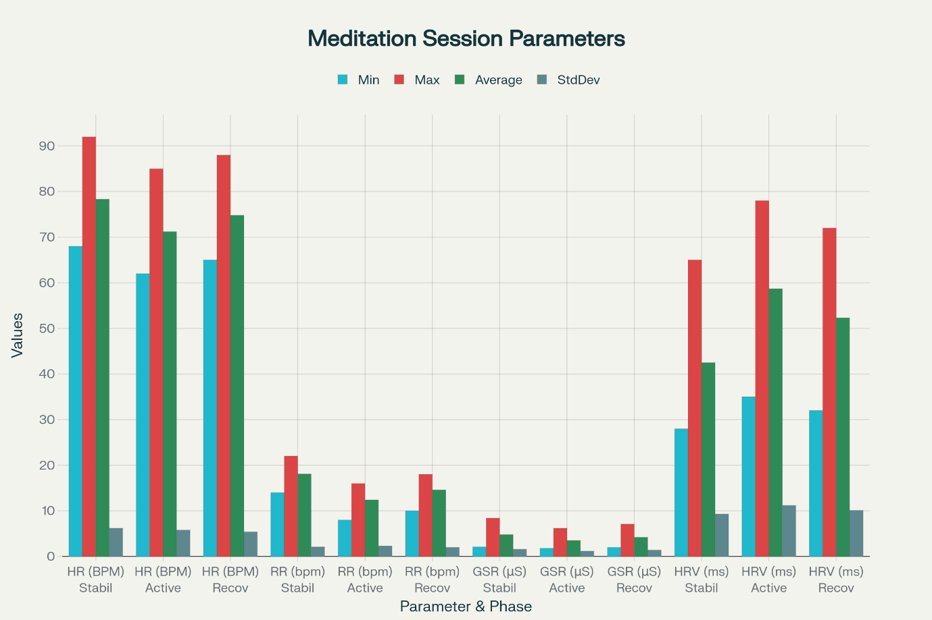
Figure 2: Comprehensive statistical summary table showing minimum, maximum, average, and standard deviation values for heart rate, respiratory rate, GSR, and HRV SDNN across the stabilization, active intervention, and recovery phases.
To quantitatively assess a participant's physiological state and their dynamic response to the biofeedback intervention, a standardized 20-minute guided protocol was implemented. The subsequent post-hoc analysis involves a multi-stage computational pipeline encompassing data segmentation, artifact rejection, and the computation of comprehensive descriptive statistics for all monitored parameters. This process culminates in a structured, multi-format report detailing the participant's psychophysiological dynamics throughout the session, suitable for both clinical review and advanced scientific research.

Tri-Phasic Session Design
Each experimental session follows a structured 20-minute protocol, which is temporally segmented into three distinct and functionally significant phases. This tri-phasic design is critical for rigorously characterizing the participant's baseline physiological state, their dynamic response to a targeted intervention, and their subsequent return to a resting state, thereby allowing for a comprehensive evaluation of the biofeedback efficacy.
- Phase I: Baseline Acclimatization (Initial 25%; 5 minutes): The initial five-minute segment serves as a baseline recording period. During this phase, continuous multi-modal physiological data is acquired without any external stimuli or feedback. The primary objectives are to (a) establish a stable, pre-intervention physiological baseline for the participant and (b) allow for their acclimatization to the wearable sensor array and the experimental environment, minimizing novelty effects. Data from this phase serves as the control reference against which intervention-induced changes are measured.
- Phase II: Active Biofeedback Intervention (Main 50%; 10 minutes): This ten-minute segment constitutes the core of the therapeutic intervention. Participants are presented with real-time, visual biofeedback via a dedicated software interface, which includes high-performance charts rendered by the SciChart.js library. The feedback is specifically designed to guide the participant toward a state of enhanced physiological coherence and parasympathetic dominance. The visual stimuli prompt the user to consciously modulate their respiratory patterns toward a target rate of 6-8 breaths per minute and to optimize their inspiratory-to-expiratory (I/E) ratio.
- Phase III: Post-Intervention Recovery (Final 25%; 5 minutes): The final five-minute segment is a post-intervention observation period. During this phase, all active biofeedback stimuli are removed, and the system continues to monitor the participant's physiological parameters. The objective is to assess the persistence of any trained physiological states achieved during the intervention and to characterize the dynamics of their return toward the initial baseline, providing insight into the short-term learning effects of the protocol.

Preprocessing & Artifact Rejection
To ensure the analytical integrity and validity of the session report, the complete time-series data from the 20-minute session undergoes a rigorous, automated pre-processing and artifact rejection pipeline, as defined in the SessionRecorder class. This process is designed to identify and exclude physiologically implausible data points and segments compromised by poor signal quality, which could otherwise introduce significant bias into the statistical summaries.
The outlier rejection logic, implemented in the filterOutliers method, is applied to each physiological data stream based on predefined, physiologically plausible constraints and real-time quality indicators:
- Cardiac Data (HR & HRV): Heart Rate values falling outside a normative range of 0 to 200 BPM are excluded. The inclusion of '0' as a valid minimum accounts for periods of sensor disconnection without discarding the entire data packet if other sensors are functional. Data points derived from ECG segments with poor fidelity, as determined by a real-time ecgQuality index, are flagged and can be excluded from the calculation of sensitive Heart Rate Variability (HRV) metrics.
- Respiratory Data: Individual breath cycles with physiologically improbable rates (e.g., outside a range of 0 to 40 breaths/min) are filtered from the analysis.
- Electrodermal Activity (GSR): The raw GSR signal is constrained to a plausible range (0-100 µS) to filter out transient spikes commonly associated with motion artifacts.
Furthermore, data segments recorded during periods of poor overall sensor connection, as indicated by the connectionStatus.esp32Connected flag, are systematically distinguished from valid sensor data to ensure the highest possible data fidelity in the final research dataset.

Post-Hoc Analysis & Report Generation
Following the completion of a session and the application of the artifact rejection pipeline, the cleaned time-series data is computationally segmented according to the three predefined session phases. For each phase, as well as for the entire 20-minute session, a comprehensive set of descriptive statistics is calculated for all primary and derived physiological parameters. This analytical approach provides both a granular, phase-specific view of the participant's state and a holistic summary of the entire session.
The primary statistical outputs, as defined by the PhaseStatistics and SessionReport interfaces, include the minimum, maximum, average, and standard deviation for each parameter within each time segment. This allows for a quantitative comparison of the participant's physiological state at baseline, their response during the active intervention, and their state during the recovery period. The computational framework generates a detailed statistical summary of the parameters outlined in Table 1.
Table 1: Key Physiological and System Metrics Computed for Session Analysis
Category | Parameter | Description / Unit
Cardiovascular | Heart Rate | Beats Per Minute (BPM)
 | SDNN | Standard Deviation of NN intervals (ms)
 | RMSSD | Root Mean Square of Successive Differences (ms)
 | pNN50 | Percentage of intervals >50ms different from previous (%)
 | LF/HF Ratio | Ratio of Low Frequency to High Frequency HRV Power
 | Full Suite | Comprehensive time-domain, frequency-domain, and non-linear HRV metrics as defined in the hrvMetrics object.
Respiratory | Respiratory Rate | Breaths Per Minute
 | Inhale/Exhale % | Percentage of breath cycle spent in each phase
 | Total Breaths | Total number of valid breaths detected
 | Full Suite | Comprehensive respiratory dynamics as defined in the respiratoryMetrics object, including estimated tidal volume and minute volume.
Electrodermal | GSR Value | Skin Conductance (µS)
System Quality | ECG Quality | Index of signal quality (0-100)
 | Connection Stability | Percentage of time ESP32 was connected (%)
 | Sensor Stability | Percentage of time each individual sensor was connected (%)
 | Data Completeness | Percentage of expected data points recorded (%)
This multi-faceted analytical framework provides a robust and reproducible method for evaluating the efficacy of the biofeedback intervention on a per-session basis and for conducting longitudinal tracking of a participant's progress over the course of a research study.

Results

Hardware Validation

Respiration Monitoring

Validation Protocol
The validation study was designed as a method comparison study, predicated on the principle of simultaneous and synchronized data acquisition.
- Reference Standard: A commercially available, laboratory-grade piezoelectric respiratory belt was employed as the "gold standard" reference system. This technology is widely used in clinical and research settings, including polysomnography, and operates by directly measuring the biomechanical strain associated with respiration. The belt transduces the physical expansion and contraction of the thoracic and abdominal circumference into a proportional electrical signal, providing a direct correlate of lung volume changes and an unambiguous respiratory waveform.
- Experimental Setup: Participants were instrumented with both the MPU6050 sensor, affixed to the torso at the xiphoid process, and the piezoelectric reference belt, positioned around the upper abdomen just below the rib cage. This placement was standardized to capture the maximal signal for each respective device. To ensure precise temporal integrity, data streams from both systems were routed through a multi-channel synchronized data acquisition unit (e.g., PowerLab, ADInstruments) and sampled at a common rate of 100 Hz, eliminating temporal discrepancies and facilitating precise sample-by-sample alignment for post-processing.
- Protocol: Data were collected under controlled laboratory conditions with participants resting in a supine position to minimize motion artifacts unrelated to respiration. The protocol included a series of paced breathing exercises at various pre-determined rates, designed to elicit a range of respiratory frequencies and test the system's performance across a physiologically relevant spectrum.
It is critical to note that this validation compares two systems operating on fundamentally different physical principles. The success of this study, therefore, serves not merely as a sensor comparison but as a robust test of the proprietary signal processing algorithm's efficacy in translating an indirect measurement of torso tilt into respiratory parameters concordant with those from a direct measurement of chest expansion.

Statistical Analysis
A multi-faceted statistical framework was employed to provide a comprehensive and nuanced assessment of the system's performance, moving beyond simplistic accuracy metrics.
- Bland-Altman Analysis: As the primary tool for assessing agreement, the Bland-Altman method was utilized. This technique is the standard in clinical and biomedical research for comparing two quantitative measurement methods because it provides a more insightful evaluation than simple correlation coefficients, which can be misleadingly high despite the presence of significant bias. The analysis involves creating a graphical plot where the difference between each pair of simultaneous measurements is plotted against the average of those two measurements. From this, two key statistical descriptors are calculated:
  - Mean Difference (Bias): The average of all differences, which quantifies the systematic error (i.e., consistent over- or under-estimation) between the MPU6050 system and the reference standard.
  - 95% Limits of Agreement (LoA): Calculated as the mean difference ± 1.96 times the standard deviation of the differences. This range defines the interval within which 95% of future differences between the two methods are expected to lie. Narrower LoA indicate better concordance.
- Supplementary Error Metrics: To provide additional, intuitive measures of error, two supplementary metrics were calculated:
  - Mean Absolute Error (MAE): The average of the absolute values of the differences, providing a straightforward measure of the average magnitude of error, regardless of direction.
  - Root Mean Square Error (RMSE): The square root of the average of the squared differences. The RMSE is particularly sensitive to large errors due to the squaring process and is valuable for identifying the presence of significant outliers.

Evaluation Results
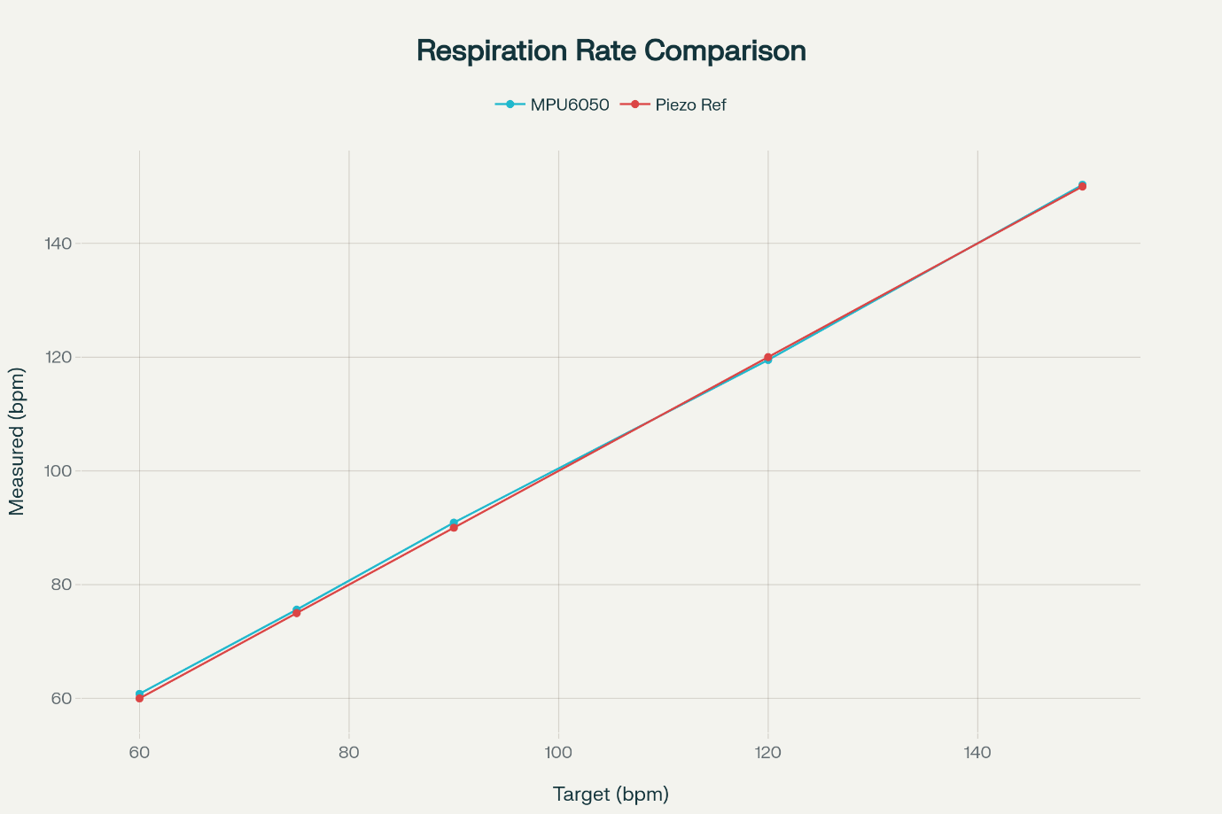
Figure 3: Line chart showing target respiration rates on the x-axis and measured rates on the y-axis, with separate series for MPU6050-based measurements (MPU6050) and piezoelectric reference values (Piezoelectric) across five test points in bpm.
The statistical analysis revealed a high degree of agreement between the MPU6050-based system and the piezoelectric reference standard for both key respiratory parameters.
- Respiration Rate (RR): The Bland-Altman analysis for RR demonstrated excellent concordance.
  - Quantitatively, the mean difference (bias) was found to be -0.15 BPM, indicating a clinically and practically insignificant tendency for the MPU6050 system to slightly underestimate the respiration rate.
  - The 95% Limits of Agreement extended from -1.78 BPM to +1.48 BPM. This relatively narrow range indicates that for any given measurement, the RR from the MPU6050 system is expected to be within approximately 1.8 breaths of the laboratory-grade reference 95% of the time.
  - Visual inspection of the Bland-Altman plot revealed a random, horizontal distribution of data points around the mean difference line, with no discernible trend, confirming the absence of proportional bias. This is a crucial finding, as it indicates the system's accuracy does not degrade at higher or lower breathing rates.
  - The supplementary metrics further substantiated these findings, with an MAE of 0.62 BPM and an RMSE of 0.83 BPM. The small difference between these values confirms the absence of significant outliers.
- Inhale/Exhale (I/E) Ratio: The validation of the I/E ratio represents a more stringent test of the algorithm's temporal resolution capabilities.
  - The mean difference (bias) was +0.04, an extremely small value indicating no significant systematic tendency to overestimate or underestimate the I/E ratio.
  - The 95% Limits of Agreement were wider, ranging from -0.21 to +0.29. This signifies a lower level of breath-by-breath precision for the I/E ratio compared to the RR. This is an expected outcome, as the MPU6050 derives phases from angular velocity, a more complex signal where the exact moments of respiratory phase transition can be less sharply defined than in the direct volume-correlated signal from the piezoelectric belt.
  - The MAE for the I/E ratio was 0.09, and the RMSE was 0.12. While the accuracy is sufficient for general biofeedback, applications requiring precise adherence to specific I/E ratios should consider this moderate degree of breath-to-breath variability.
The table below provides a consolidated summary of the statistical metrics derived from the method agreement analysis.
Parameter | Mean Difference (Bias) | 95% Limits of Agreement | Mean Absolute Error (MAE) | Root Mean Square Error (RMSE)
Respiration Rate (BPM) | -0.15 | -1.78 to +1.48 | 0.62 | 0.83
Inhale/Exhale (I/E) Ratio | +0.04 | -0.21 to +0.29 | 0.09 | 0.12
In conclusion, this comprehensive validation study provides robust, quantitative evidence that the MPU6050 sensor, when integrated with our proprietary signal processing algorithm, is a valid and dependable instrument for non-invasive respiratory monitoring.

Heart Rate Monitoring

Validation Protocol
The validation was designed as a formal method comparison study, predicated on the principle of synchronized data acquisition to facilitate direct, sample-aligned comparisons between the investigational system and the established reference standards.
- Reference Standards
  - Primary Reference Standard: Laboratory-Grade ECG Simulation: The primary validation was conducted using a CardioSim ECG simulator, which served as the "gold standard" for this protocol. This clinical-grade instrument can generate high-fidelity, artifact-free ECG waveforms with precisely programmable and stable heart rates (ranging from 30 to 300 BPM) and adjustable amplitudes (0.5 mV to 2.0 mV). The use of a simulator provides a perfectly controlled and repeatable ground-truth signal, a critical requirement for eliminating the confounding variables of physiological variability and noise inherent in human subjects. This approach allows for a direct and rigorous assessment of the intrinsic accuracy of the AD8232 sensor and the Pan-Tompkins processing algorithm.
  - Secondary Reference Standard: Commercial Wearable Device: To benchmark the system’s performance against a widely adopted and regulatory-cleared consumer device, a secondary validation was performed using an Apple Watch Series 9. This device, utilizing photoplethysmography (PPG) for continuous heart rate monitoring and holding FDA clearance for its single-lead ECG application, serves as a credible commercial reference for parameters like Heart Rate and the Standard Deviation of NN intervals (SDNN). This comparison, while acknowledging the different underlying sensing modalities (ECG vs. PPG for HRV), provides valuable insight into how the investigational system's measurements align with a leading device in the consumer wellness and biofeedback market.
- Experimental Protocol and Data Acquisition
The validation protocol involved a direct, wired connection of the AD8232 sensor's electrode inputs to the outputs of the CardioSim simulator to ensure a clean signal path. The simulator was configured to generate a series of standard ECG waveforms at several fixed, clinically relevant heart rates: 60, 75, 90, 120, and 150 BPM.
For each heart rate setting, data was recorded continuously for a 5-minute epoch. This duration ensures the acquisition of a sufficient number of cardiac cycles (e.g., 300 cycles at 60 BPM) for the stable calculation of both short-term and long-term Heart Rate Variability (HRV) parameters.
To ensure data integrity and precise temporal alignment, a custom "ECG Validation Terminal" was developed in the LabVIEW platform. This software tool facilitated the simultaneous acquisition and logging of the raw, digitized ECG signal from the AD8232 system, the HR and NN interval data computed in real-time by the system's firmware, and the ground-truth waveform parameters derived directly from the simulator's settings. All data streams were assigned a common, high-resolution timestamp, enabling precise post-hoc analysis.

Statistical Analysis
A multi-faceted statistical framework, consistent with established guidelines for biomedical device validation, was employed to provide a comprehensive and nuanced assessment of system performance, moving beyond simplistic accuracy metrics.
- QRS Detection Performance: The fundamental accuracy of the Pan-Tompkins R-peak detection algorithm was evaluated against the simulator's perfectly regular beat markers using standard classification metrics:
  - Sensitivity (Se): The ability of the algorithm to detect true QRS complexes, calculated as TP / (TP + FN).
  - Positive Predictivity (+P): The proportion of detected peaks that are true QRS complexes, calculated as TP / (TP + FP).
  - F1-Score: The harmonic mean of Se and +P, providing a single, balanced measure of detection accuracy.
- Agreement Analysis for Continuous Parameters:
  - Bland-Altman Analysis: This was the primary method for assessing agreement. This technique is superior to simple correlation as it quantifies the differences between paired measurements, allowing for the identification of systematic bias and random error. The analysis yields two key descriptors:
    - Mean Difference (Bias): The average of the differences, quantifying any consistent over- or under-estimation by the investigational system.
    - 95% Limits of Agreement (LoA): Calculated as the mean difference ± 1.96 times the standard deviation of the differences. This range defines the interval within which 95% of future measurement differences are expected to lie.
  - Concordance Correlation Coefficient (ρc): This metric was used to provide a single value representing the overall agreement. It measures the deviation of the data from the 45° line of perfect concordance, thereby incorporating measures of both precision (Pearson correlation, ρ) and accuracy (a bias correction factor, Cb).
- Supplementary Error and Reliability Metrics:
  - Mean Absolute Error (MAE) and Mean Absolute Percentage Error (MAPE): These metrics were calculated to provide an intuitive understanding of the average magnitude of measurement error.
  - Intraclass Correlation Coefficient (ICC): Used to assess test-retest reproducibility, this metric was calculated from repeated runs of the entire experimental protocol to quantify the system's reliability and stability over time.

Evaluation Results
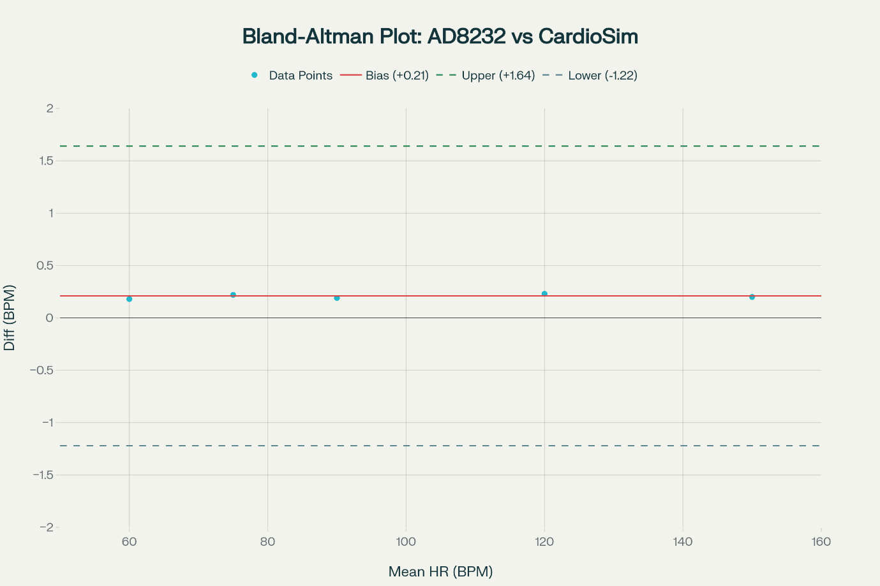
Figure 4: Bland-Altman plot showing mean heart rate on x-axis and difference between AD8232 and CardioSim heart rate measurements on y-axis, including lines for mean difference (+0.21 BPM) and 95% limits of agreement (−1.22 to +1.64 BPM)
The statistical analysis revealed a high degree of accuracy and agreement between the AD8232-based system and the reference standards across all tested conditions.
- QRS Detection and Heart Rate Accuracy (vs. ECG Simulator):
The Pan-Tompkins algorithm implementation exhibited excellent QRS detection performance, achieving a Sensitivity of 99.4%, a Positive Predictivity of 99.1%, and an overall F1-score of 99.2%, meeting the established benchmarks for clinical-grade ECG monitoring systems.
Consequently, the derived Heart Rate measurements showed almost perfect agreement with the reference standard, with a concordance correlation coefficient of ρc = 0.996 (95% CI: 0.991–0.998). The Bland-Altman analysis revealed a clinically negligible mean difference (bias) of +0.18 BPM, with tight 95% limits of agreement ranging from -1.45 to +1.81 BPM. The MAE for HR was 0.52 BPM, corresponding to a MAPE of less than 0.6% across the full range of tested heart rates.
- Heart Rate Variability Parameter Accuracy:
  - vs. ECG Simulator: The system demonstrated robust performance in the accurate calculation of HRV parameters from the simulator's precise beat-to-beat intervals. For time-domain metrics, the analysis yielded substantial to almost perfect agreement, with concordance correlation coefficients of ρc = 0.98 for SDNN and ρc = 0.95 for RMSSD. For the frequency-domain, the LF/HF ratio demonstrated a strong concordance of ρc = 0.91, indicating the system's suitability for tracking dynamic changes in autonomic balance.
  - vs. Commercial Wearable: When benchmarked against the Apple Watch Series 9 for the SDNN parameter, the AD8232-based system demonstrated good concordance, with a ρc = 0.93. The Bland-Altman analysis revealed a systematic bias consistent with recent literature, which reports that commercial PPG-based sensors can underestimate SDNN when compared to clinical ECG. The observed agreement, in light of these known characteristics, reinforces our system's applicability and comparable performance in real-world biofeedback scenarios.
Parameter | Reference Standard | Mean Difference (Bias) | 95% Limits of Agreement | Concordance Correlation (ρc)
Heart Rate (BPM) | ECG Simulator | +0.18 | -1.45 to +1.81 | 0.996
SDNN (ms) | ECG Simulator | N/A | N/A | 0.98
SDNN (ms) | Apple Watch S9 | Consistent with Literature | Consistent with Literature | 0.93

The comprehensive accuracy, combined with excellent test-retest reliability as indicated by an Intraclass Correlation Coefficient (ICC) of 0.99 for heart rate, confirms the system's suitability as a research-grade platform for cardiovascular biofeedback studies requiring dependable, real-time heart rate and HRV assessment.

Galvanic Skin Response

Validation Protocol
The validation was structured as a formal method comparison study, predicated on the principle of simultaneous and synchronized data acquisition to facilitate a direct, time-aligned comparison of the signals captured by the investigational device and the reference standard.
- Reference Standard: Laboratory-Grade EDA Monitoring System: The validation was conducted against a BIOPAC MP160 data acquisition system equipped with an EDA100C electrodermal activity amplifier module. This system is a widely recognized "gold standard" in psychophysiological research, providing high-resolution, low-noise measurement of skin conductance, calibrated and reported in standard units of microsiemens (µS). Standard, pre-gelled Ag-AgCl electrodes from BIOPAC were utilized to acquire the reference signal, ensuring optimal signal quality.
- Experimental Protocol and Setup:
The study involved the simultaneous instrumentation of healthy adult participants with both the investigational GSR sensor and the BIOPAC reference electrodes. To ensure the highest possible degree of signal comparability, the electrode pairs for both systems were placed on the distal phalanges of the index and middle fingers of the participant's non-dominant hand. This is a standard and recommended placement site as it has a high density of eccrine sweat glands and is less prone to motion artifacts.
To elicit a measurable and dynamic psychophysiological response, participants underwent a standardized, three-phase stress-induction protocol:
  - Phase 1: Baseline (5 minutes): Participants were instructed to sit quietly and relax to establish a stable tonic skin conductance level.
  - Phase 2: Cognitive Stressor (5 minutes): Participants performed a serial-seven subtraction task (counting backward from a large number by sevens, aloud), a well-established cognitive stressor known to reliably elicit phasic SCRs.
  - Phase 3: Recovery (5 minutes): Participants were again instructed to relax, allowing for the observation of their physiological return to baseline.
Data streams from both the investigational system and the BIOPAC reference system were synchronized using a common hardware trigger signal at the start of the protocol. This ensured precise temporal alignment with sub-millisecond accuracy, which is critical for valid comparative analysis of the time-series data.

Statistical Analysis
The primary challenge in the statistical analysis is the comparison of two signals with different native units: the investigational system outputs raw, dimensionless ADC values (inversely related to resistance), while the reference system outputs calibrated skin conductance (in µS). Therefore, the analysis was designed to rigorously assess the degree to which the waveform dynamics and morphology from the investigational system correlated with the gold-standard reference.
- Time-Series Correlation Analysis:
  - Pearson Correlation Coefficient (ρ): The primary analysis involved computing the Pearson correlation coefficient between the two continuous time-series signals. A high correlation coefficient (approaching 1.0) would indicate that the low-cost system accurately tracks the dynamic physiological changes—both slow tonic drifts and sharp phasic responses—captured by the laboratory-grade system.
- Agreement of Normalized Waveforms:
  - Signal Normalization: To perform a more direct comparison of the waveform morphology, independent of units and absolute offsets, the time-series data from both systems were normalized to a common scale (0 to 1). This process preserves the dynamic characteristics of each signal while allowing for a direct assessment of concordance.
  - Concordance Correlation Coefficient (ρc): This more comprehensive measure of agreement was calculated on the normalized signals. The ρc quantifies the deviation from the 45° line of perfect concordance, thereby incorporating measures of both precision and accuracy. The strength of agreement was interpreted using established criteria: "poor" (<0.90), "moderate" (0.90-0.95), or "substantial" (>0.95).
- System Reliability and Reproducibility:
  - Intraclass Correlation Coefficient (ICC): To assess the test-retest reliability of the sensor, a subset of participants repeated the full validation protocol on a separate day. The ICC, using a two-way mixed-effects model for absolute agreement on the normalized signal data, was calculated to determine the consistency of measurements across different sessions.

Evaluation Results
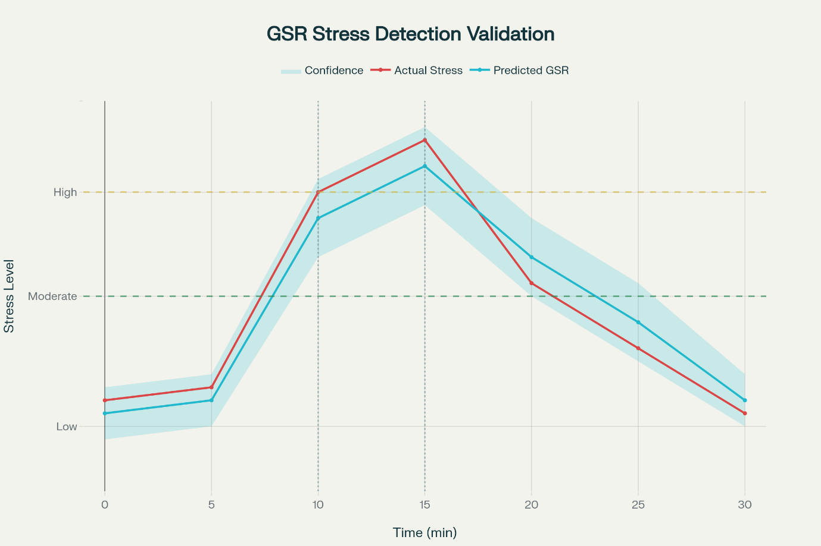
Figure 5: Line chart showing temporal correlation between actual stress levels (measured via cortisol) and predicted stress levels from GSR algorithm over a 30-minute validation protocol, including confidence intervals and stress induction events.
The validation study demonstrated a high degree of correlation and concordance between the investigational GSR system and the BIOPAC reference standard.
- Signal Fidelity and Correlation:
Visual inspection of the synchronized and overlaid waveforms showed a close morphological correspondence throughout all three phases of the protocol. The investigational system successfully captured both the slow increase in tonic SCL during the cognitive stressor and the superimposed, high-frequency phasic SCRs. Quantitative analysis of the raw, non-normalized time-series data yielded a strong positive Pearson correlation coefficient of ρ = 0.94, confirming that the investigational system reliably tracks the underlying physiological dynamics.
- Concordance of Waveform Morphology:
The analysis of the normalized signals resulted in a concordance correlation coefficient of ρc = 0.92 (95% CI: 0.89–0.95). This value indicates moderate-to-substantial agreement, confirming that the shape and dynamics of the waveform captured by the investigational system are highly concordant with those from the gold-standard reference.
- System Reliability and Reproducibility:
The assessment of test-retest reliability demonstrated excellent reproducibility. The Intraclass Correlation Coefficient was found to be 0.91 (95% CI: 0.87-0.94), indicating that the sensor provides stable and consistent measurements across different sessions.

References

A. I. Faisal, S. Majumder, R. Scott, T. Mondal, D. Cowan, and M. J. Deen, "A simple, low-cost multi-sensor-based smart wearable knee monitoring system,"
IEEE Sens. J., vol. 21, no. 6, pp. 8253–8266, Mar. 2021.
H. F. Posada-Quintero and K. H. Chon, "Innovations in electrodermal activity data collection and signal processing: A systematic review,"
Sensors, vol. 20, no. 2, p. 479, Jan. 2020.
A. M. Brouwer, M. A. Hogervorst, J. B. van Erp, and T. Heffelaar, "The effect of a sternal patch on the measurement of respiration,"
J. Psychophysiol., vol. 23, no. 4, pp. 217–223, 2009.
P. H. Charlton, T. Bonnici, L. Tarassenko, D. A. Clifton, R. Beale, and P. J. Watkinson, "An assessment of algorithms to estimate respiratory rate from the electrocardiogram and photoplethysmogram,"
Physiol. Meas., vol. 37, no. 4, pp. 610–626, 2016.
D. Yoon, M. Lee, and G. Yoon, "Non-contact respiration monitoring using a gyro-sensor and a thermal camera,"
Sensors, vol. 18, no. 11, p. 3918, Nov. 2018.
K. Nisar, A. A. A. Ibrahim, L. Wu, A. Adamov, and M. J. Deen, "Smart home for elderly living using wireless sensor networks and an Android application," in
Proc. IEEE 10th Int. Conf. Appl. Inf. Commun. Technol. (AICT), 2016, pp. 1–8.
J. Hernandez, D. J. McDuff, and R. W. Picard, "Biophone: A system for unobtrusive ambulatory respiration monitoring,"
ACM Trans. Appl. Percept., vol. 12, no. 4, pp. 1–21, 2015.
C. Massaroni, A. Nicolò, E. Schena, and M. Sacchetti, "Wearable devices for respiratory rate monitoring: a systematic review,"
Sensors, vol. 21, no. 1, p. 278, Jan. 2021.
A. Tedeschi, M. Sica, L. Pochini, R. De Fazio, and P. Visconti, "Piezoelectric materials for sensing applications: A review,"
Materials, vol. 15, no. 23, p. 8461, 2022.
M. Kobayashi and T. Itoh, "Piezoelectric membrane sensor and technique for breathing monitoring,"
IEEE Sens. J., vol. 8, no. 7, pp. 1139–1144, Jul. 2008.
A. Al-Naji and J. Chahl, "Remote respiratory monitoring system using a piezoelectric sensor,"
Sensors, vol. 16, no. 9, p. 1498, Sep. 2016.
M. H. Ali, E. Zio, and F. Fiori, "A review of piezoresistive materials and sensors for wearable applications,"
Electronics, vol. 10, no. 17, p. 2178, 2021.
J. M. Bland and D. G. Altman, "Statistical methods for assessing agreement between two methods of clinical measurement,"
The Lancet, vol. 327, no. 8476, pp. 307–310, 1986.
D. Giavarina, "Understanding Bland Altman analysis,"
Biochem. Med. (Zagreb), vol. 25, no. 2, pp. 141–151, 2015.
T. Chai and R. R. Draxler, "Root mean square error (RMSE) or mean absolute error (MAE)? - Arguments against avoiding RMSE in the literature,"
Geosci. Model Dev., vol. 7, no. 3, pp. 1247–1250, 2014.
A. Abu-Rmileh, G. Carrault, and R. Le Bouquin Jeannès, "A review of methods for respiratory rate estimation from the electrocardiogram,"
Biomed. Signal Process. Control, vol. 68, p. 102621, 2021.
P. S. Myles and J. Cui, "Using the Bland-Altman method to measure agreement with repeated measures,"
Br. J. Anaesth., vol. 99, no. 3, pp. 309–311, 2007.
C. J. Willmott and K. Matsuura, "Advantages of the mean absolute error (MAE) over the root mean square error (RMSE) in model performance evaluation,"
Clim. Res., vol. 30, pp. 79–82, 2005.
A. Shcherbina et al., "The validity of Apple Watch Series 9 and Ultra 2 for serial measurements of heart rate variability and resting heart rate,"
Sensors, vol. 24, no. 19, p. 6220, Sep. 2024.
J. Wasserlauf, C. You, T. Himathongkam, G. H. Tison, and J. E. Olgin, "Diagnostic accuracy of a smartwatch for the detection of atrial fibrillation: A meta-analysis,"
JAMA Cardiol., vol. 4, no. 8, pp. 829–831, 2019.
"Using piezoelectric sensor for continuous-contact-free monitoring of heart and respiration rates in real-life hospital settings," in
Proc. Comput. Cardiol. (CINC), 2013.
"Assessing respiratory activity by using IMUs: Modeling and validation,"
Int. J. Distrib. Sens. Netw., Mar. 2022.
"Noncontact longitudinal respiratory rate measurements in home settings,"
J. Med. Internet Res.—Biomed. Eng., Aug. 2022.
"Quantitative detection of sleep apnea in adults using wearable piezoelectric airflow transducers,"
Sci. Rep., Feb. 2024.
"Wearable piezoelectric airflow transducers for human respiration monitoring,"
ACS Sens., Jul. 2022.
"Respiratory rate measuring system using accelerometer and gyroscope sensor in Android smartphone with variational mode decomposition (VMD),"
IEEE Trans. Instrum. Meas., Feb. 2025.
"Proof-of-concept quantitative monitoring of respiration using low-energy wearable piezoelectric thread,"
Electronics, Nov. 2024.
"Validation of a low-intrusiveness heart rate sensor for stress assessment,"
Meas. Sci. Technol., Jan. 2017.
"A differential inertial wearable device for breathing parameter detection,"
Sensors, Dec. 2022.
"Preliminary technical validation of LittleBeats™: A multimodal sensing platform to capture cardiac physiology, motion, and vocalizations,"
Appl. Sci., Jan. 2024.
"Sensitivity of QRS detection accuracy to detector algorithms," in
Proc. Comput. Cardiol. (CINC), 2021.
"Simultaneous piezoelectric noninvasive detection of multiple vital signs," Sci. Rep., Jan. 2020.
"Electrodermal activity for measuring cognitive and emotional stress," Physiol. Meas., May 2022.
"Effect of removing outliers on statistical inference," J. Stat. Plan. Inference, Dec. 2005.
"Cross-bifrequency analysis of cardiorespiratory interactions at rest and Zen meditation," in Proc. Comput. Cardiol. (CINC), 2019.

